IFT 266 Introduction to Network Information Communication Technology (ICT)
Lab 29
Local Link Address Configuration

Objective: Configure a simple network with IPv6 and get the hosts communicating with each other and configure the router interfaces for IPv6.

- Setup the following topology.
For this lab use the 1941 Router which by default has Gigabit interfaces.
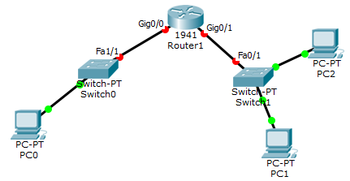



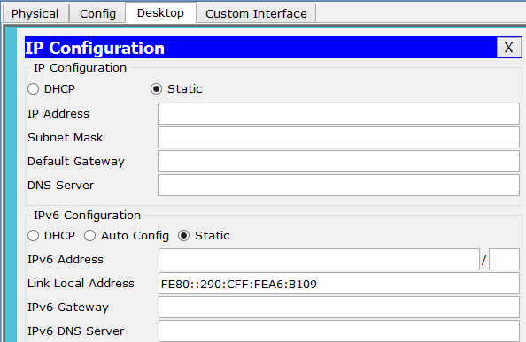
- Open PC1 and look at the IP configuration window on the desktop tab. With Packet Tracer V6 there is the ability to configure IPv6 on a PC. By default, the device already has a link local IPv6 address (starts with FE80) and the remainder is generated from the devices MAC address.

- To confirm that the MAC address is part of the link local address, run the ipconfig /all command and look at the physical address and compare it to the link local address (the numbers are included i.e. A6 B109).

In the center to create the 64-bit interface ID portion of this address, the FFFE was inserted and then the front half of the MAC address (0090.0C) is put in the front portion (some conversion is performed here so we get 0290 0C). The result is a link local address that is generated from the devices MAC address.

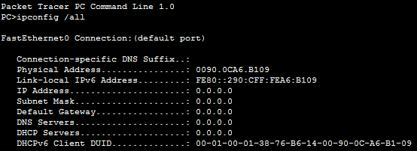

- Link local address allows the device to communicate on the local network and any device on an IPv6 network needs to have at a minimum a link local address.
- We know that both PCs (PC1 and PC2 both have a link local address), so now attempt to ping one from the other. Copy the link local address from the command prompt (on PC1) and open PC2 and ping PC1 by pasting the link local address from PC1.

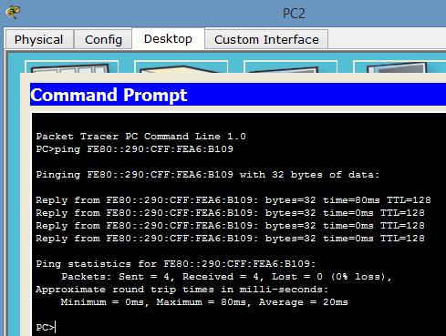

- Now we have verified that we can communicate with the link local addresses on PC1 and PC2.
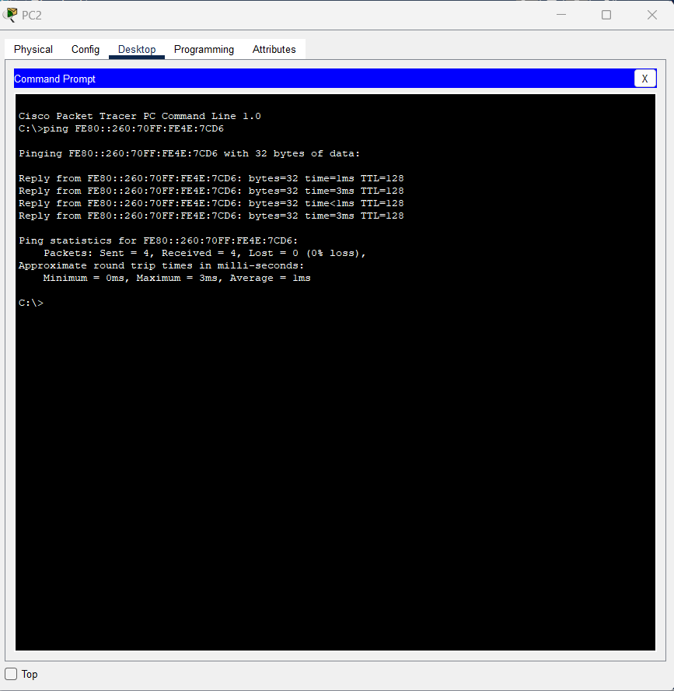

- The router will not have automatic link local address (enabled). Router has IPv6 routing disabled by default. Configurations will need to be completed to get the router to operate in an IPv6 network.
- Open the router and go into the command prompt and type the following commands.

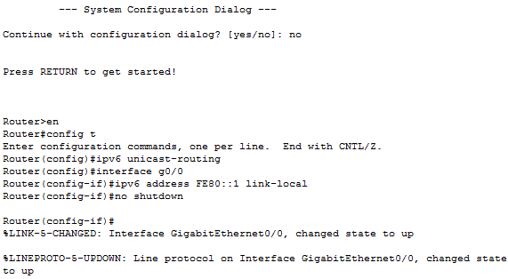

- Command Summary
- ipv6 unicast-routing: enables IPv6 unicast routing on the router. IPv6 is disabled by default.
- Interface g0/0: puts you in interface configuration mode. By using the 1941 router, it has gigabit interfaces.
- ipv6 address FE80::1 link-local. Manually configure on the router whereas with the PC it automatically self-configured. We can get it autoconfigured on the router but better to better manually as you can create a more simplistic link local address so easier to remember and work with. In this case, we created a link local address of 1 as it’s easy to remember and number of the router. Remember, the link local address in only locally significant.

- Now the interface is up and has the local link address of FE80::1. The router connection/interface should now have turned green.

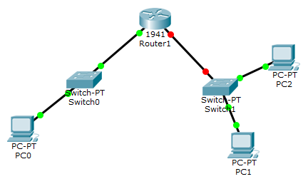

- Repeat the same procedure for the other router gigabit (g0/1) interface. We can use the same link local address on the other interface, since these link local addresses are only locally significant. These addresses do not need to uniquely identify one network from another network, so use the same address on the other interface.

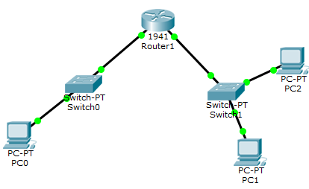

- Now both interfaces on the router have a link local address of FE80::1. We will now test it!
- Go to command prompt on PC1 and ping the routers interface FE80::1 and you should get a reply. Now we can communicate from PC to the gateway using IPv6. Should be able to do the same from PC0.

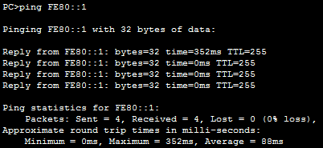

- We have now configured both sides (separate subnets). Can PC0 ping PC1 with local link addresses across the router. Yes or No and explain your reason.
Pinging won’t work across sub-nets using local-link IPv6. We would need to configure a global unicast IPv6 address (GUA)

- Whatever you decide, prove it with it a ping!
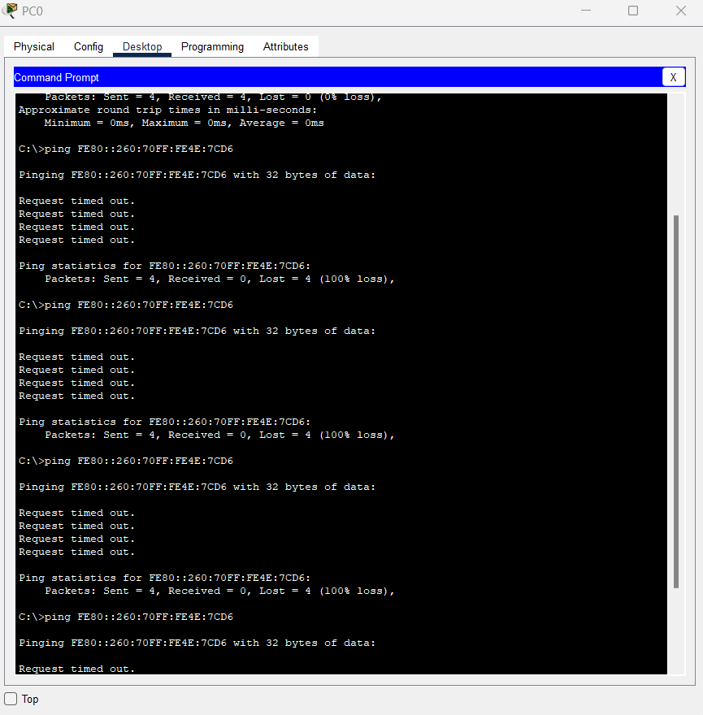

Make sure you save your packet tracer file as you will need it for lab 30

